# PokerCNN

* Represents the board with 1-hot-encoded cards. They zero pad these matrices for some obscure reason
* Use video poker to evaluate performance (what is that ?)
* Features:

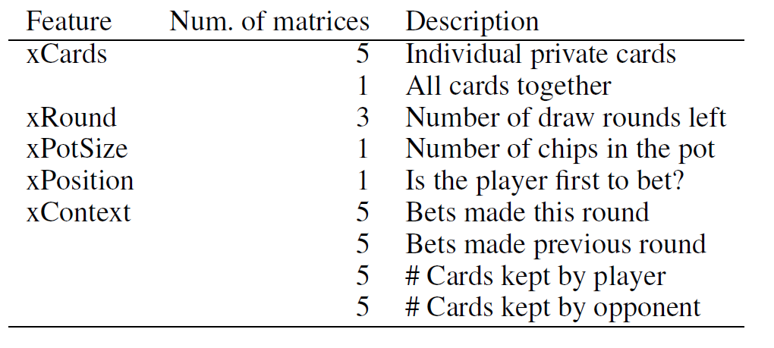

* They use a CNN to make bet. It predicts the expected value of five output states (bet,raise,check,fold,call). To generate training samples, they keep track of how many chips the action they took gained or lost. If it folds, you count 0.